catalogue
1． Equipment operation guidelines 2
2． Process introduction 3
gather 3
modeling 4
attestation 5
Certification and learning 6
3． Function introduction 7
device initialize 7
Set the device number 7
Get the device number 7
The equipment is closed 7
Establish a template 8
Quality assessment 8
1:1 Comparison 8
1: N comparison 9
Get the number of devices 9
Get finger status 9
Set the indicator light 9
Get a picture 9
Open the device 10
gather 10
Get finger status 10
Set the status of the led lamp 11
Get the number 11
Set the number 11
Determine whether the device is turned on 11
Turn off the turned-on device 12
Get the library version 12
Obtain the venous equipment information 12
Get the venous device number 12
Obthe production date of venous equipment 13
Get the default alignment threshold value 13
Load the template library 13
Search from the template library 14
Add templates to the template library 14
Remove the specified id from the template library 15
Add a new user from the specified folder for synchronization 15
4． remarks 16

Equipment operation guidelines
1. Calm down and sit up
2. Dont use your dirty or callused fingers

Process introduction

gather
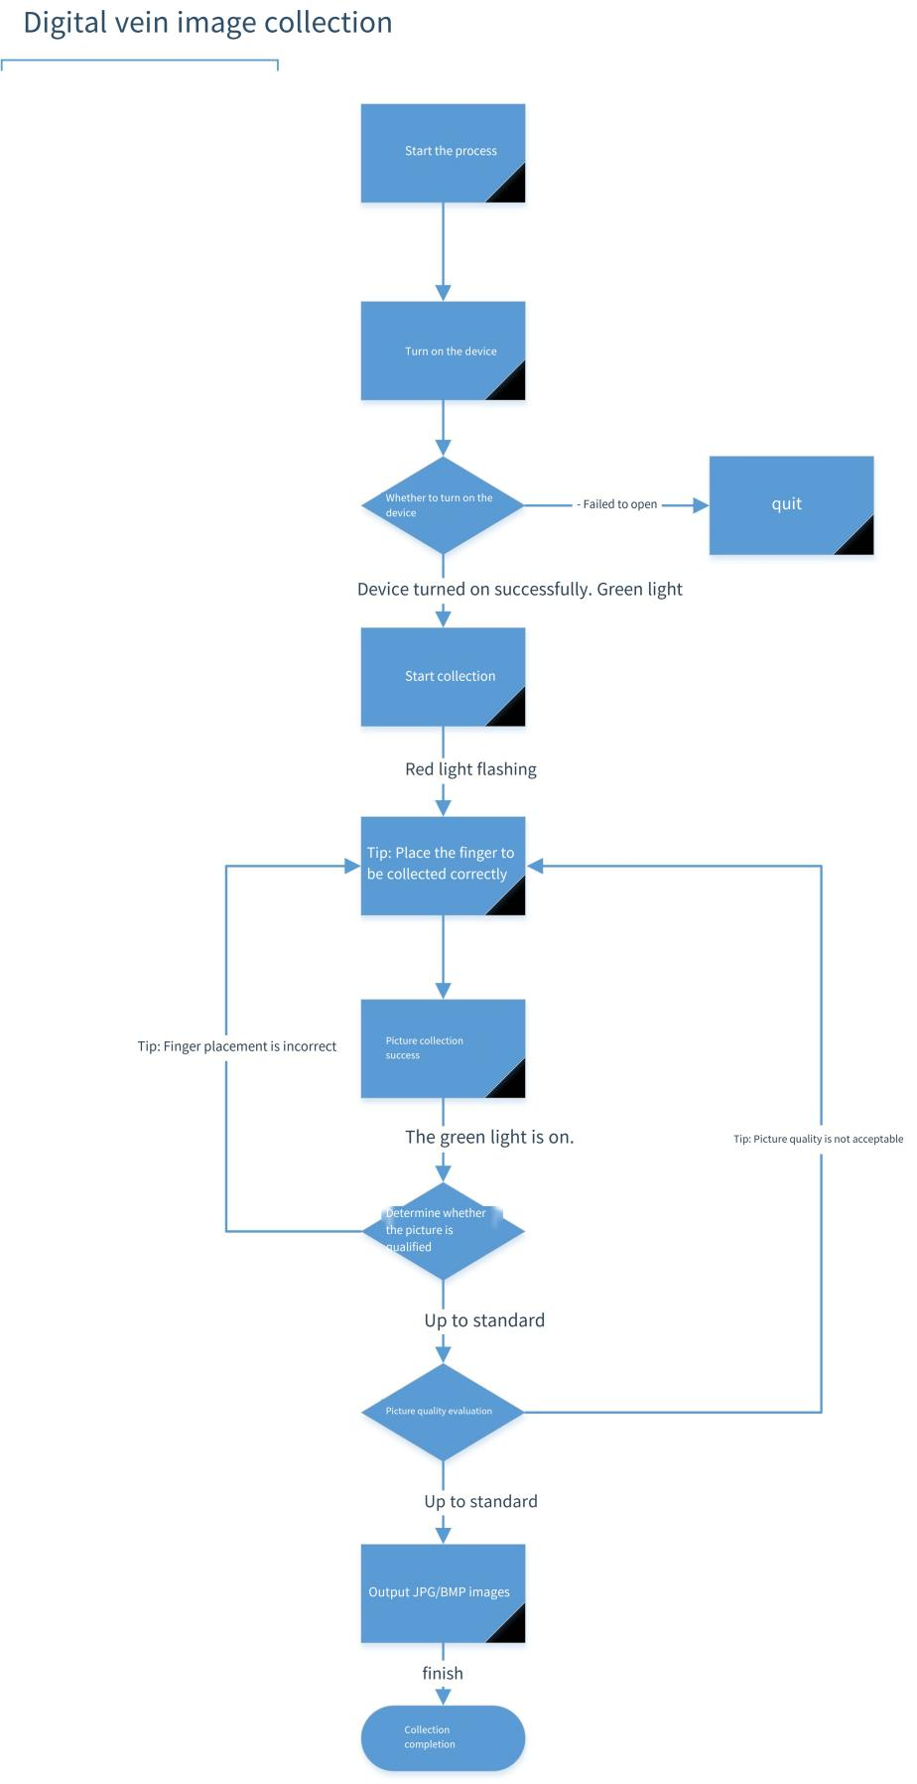

modeling
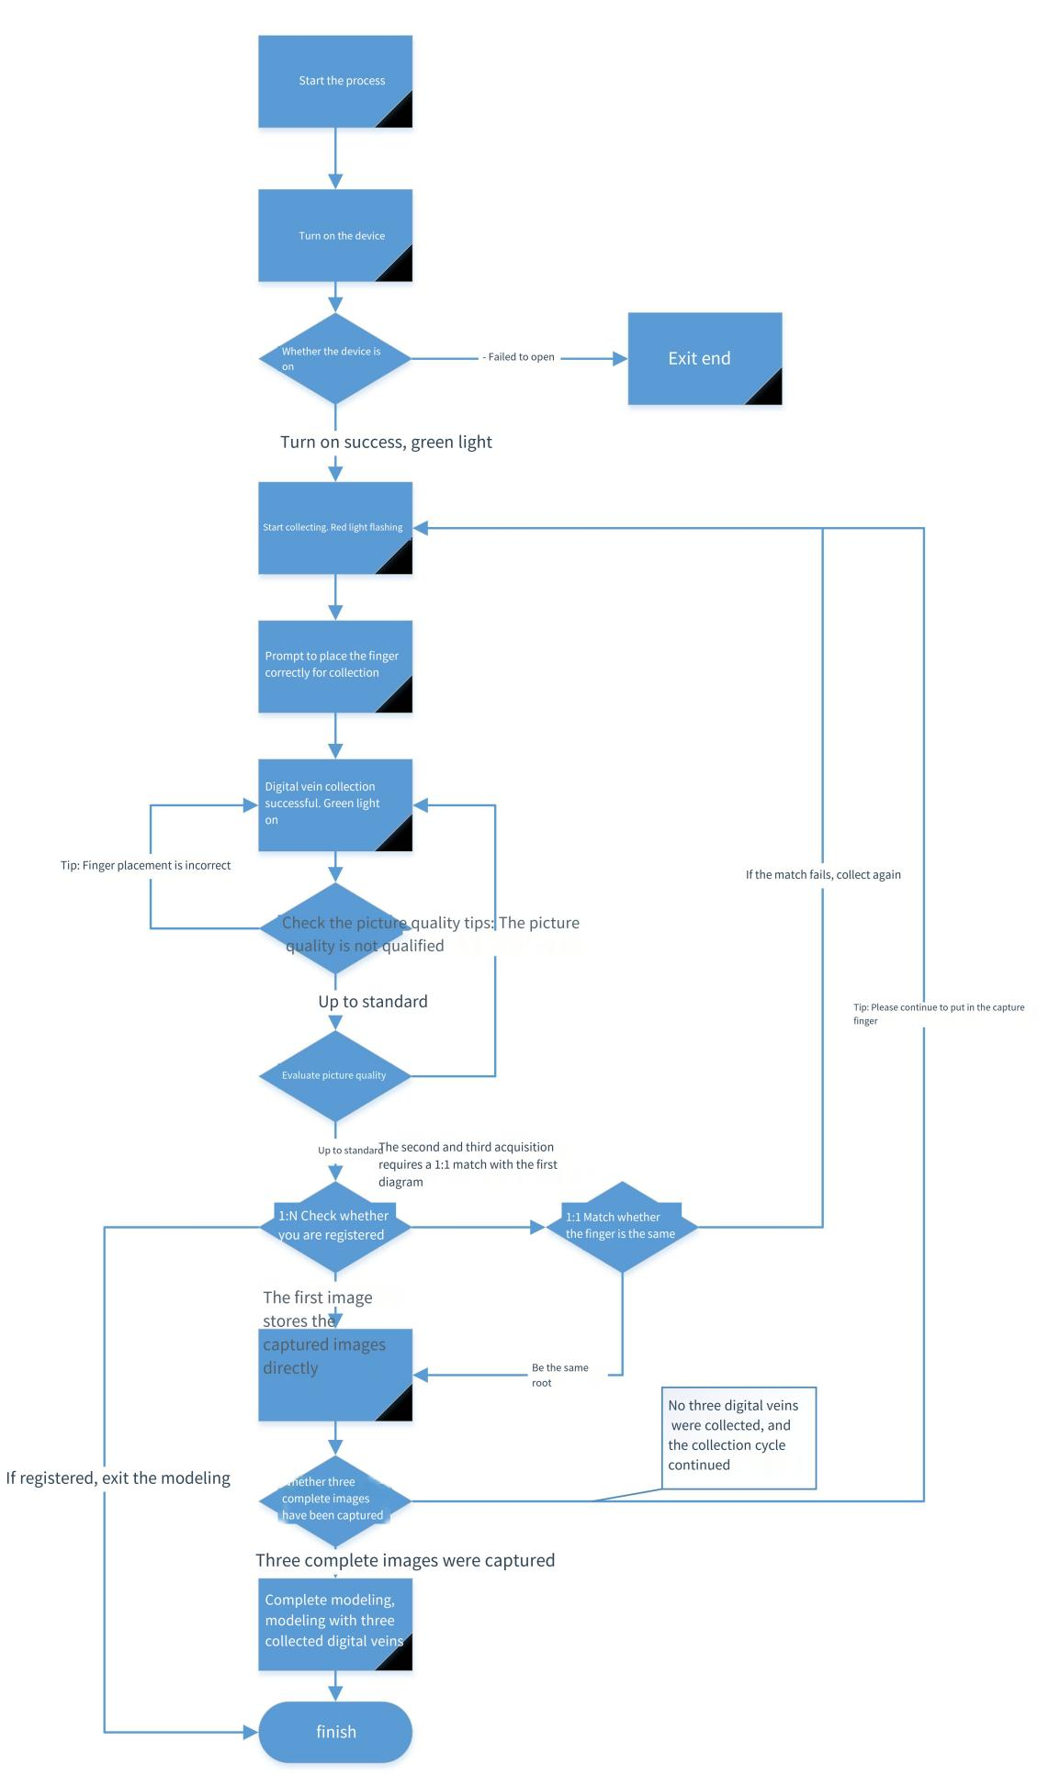

attestation
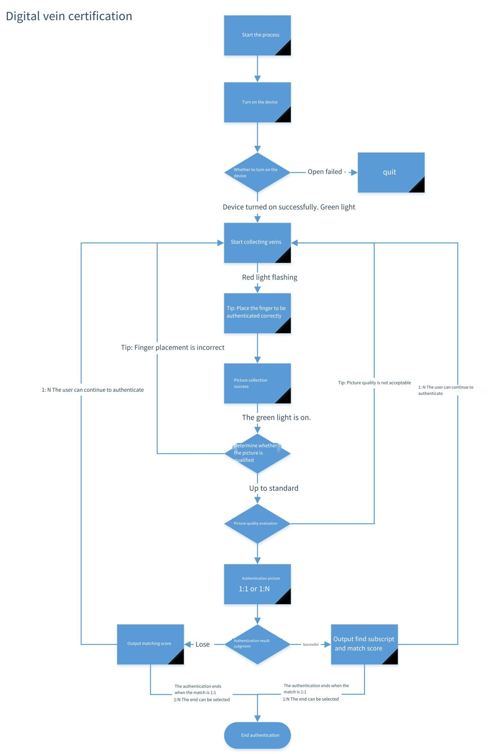

Certification and learning
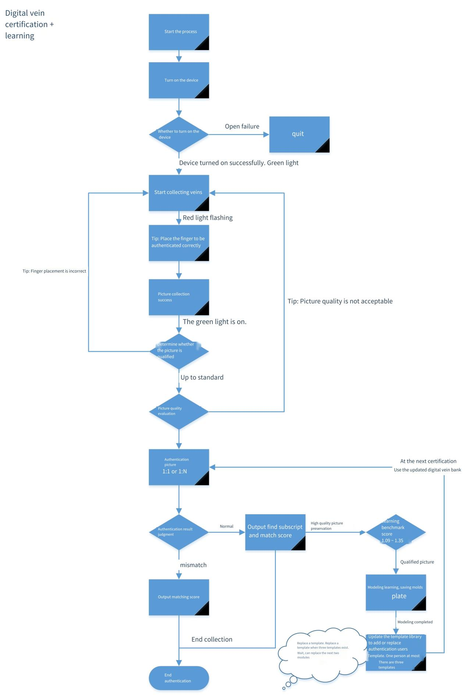

Function introduction

device initialize
function prototype | fvdev_open
Function function | Open the device
devno | Equipment Index (0,1,....)
Hwnd | The return window, in linux is a function of the picture callback,  Implementation by the user,  typedef void(*pFrameArrived)(unsigned char *pFrame, int width,int height);  pFrame: RGB data  Width: image width  Height: High level of the image

Set the device number
function prototype | fvdev_setno(int no)
Function function | Set the device number
no | number

Get the device number
function prototype | fvdev_ g etno(int *no)
Function function | Get the device number
no | number

The equipment is closed
function prototype | fvdev_close
Function function | closing device

Establish a template
function prototype | fv_extract_model
Function function | Establish a template
picData1 (Required) | Picture data 1
picLen1 (Required) | Picture data of the 1 in length
picData2 (Optional) | Picture data 2
picLen2 (Optional) | Picture data 2 length
picData3 (Optional) | Picture data 3
picLen3 (Optional) | Picture data of 3 in length
model | Template data
modelLen | The length of the template needs to be passed into a relatively large buffer, at least 4k

Quality assessment
function prototype | BOOL fv_quality(unsigned char *img, int len, int *q)
Function parameters | Function parameter meaning
img | Pictures that the img needs to compare
len | Length of the image to compare (length of the img)
q | quality:  1.q=0, indicating mass passing  2.q=2001，Bad Quality with too many pressure  3.q=2003，Light Leak
If the function returns TRUE, the function call is successful; if the function returns FALSE, the function call fails

1:1 Comparison
function prototype | BOOL fv_match(unsigned char *img, int imgLen, unsigned char*model, float *score)
Function parameters | Function parameter meaning
img | Current pictures to compare
model | One of the templates obtained in the registered template
score | Score 052- - -> 10000 0.6- -> 1000000
If the function returns TRUE, the function call is successful; if the function returns FALSE, the function call fails

1: N comparison
function prototype | BOOL index(unsigned char *models, int count,BYTE*img,int imgLen, int *pos,float *score)
Function parameters | Function parameter meaning
model | All of the registered templates
num | The number of registered templates
img | Current pictures to compare
pos | Returns the array subscript for the maximum score
score | Score 052- - -> 10000 0.6- -> 1000000
If the function returns TRUE, the function call is successful; if the function returns FALSE, the function call fails

Get the number of devices
function prototype | BOOL fvdev_get_count(int *count)
Function parameters | Function parameter meaning
count | number

Get finger status
function prototype | BOOL fvdev_get_state(int *state)
Function parameters | Function parameter meaning
state | Finger sensing state 0: no finger 1: Fingertip press 2: finger abdomen press 3: finger press

Set the indicator light
function prototype | BOOL fvdev_set_led(int Color, MD_BOOL bFlush)
Function parameters | Function parameter meaning
color | 1:0: Red: 1: green
bFlush | True: flashing false: always bright

Get a picture
function prototype | BOOL fvdev_grab(unsigned char *img, int *len)
Function parameters | Function parameter meaning
img | Allocate a large enough space to pass in, like 30,000 bytes
len | The length of the img when incoming and the actual length of the image when outgoing

Open the device
function prototype | fvdev_open_ex( int devno, HWND hwnd, void **phandle)
Function function | Open the device
devno | Equipment Index (0,1,....)
phandle | Device handle, you can operate a single device separately

gather
function prototype | fvdev_grab_ex( void* handle, unsigned char *img, int *len)
Function function | gather
handle | Device handle
img | buffer
len | buffer length

Get finger status
function prototype | fvdev_get_state_ex( void *handle, int *state)
Function function | Get the hand status
handle | Device handle
state | Finger state

Set the status of the led lamp
function prototype | fvdev_set_led_ex( void *handle, int Color, BOOL bFlush)
Function function | Status of the device led lamp
handle | Device handle
Color | Color (0: Red 1: green)
bFlush | Whether flashing

Get the number
function prototype | fvdev_getno_ex( void *handle, int* no)
Function function | Get the number
handle | Device handle
no | number

Set the number
function prototype | fvdev_setno_ex( void *handle, int no)
Function function | Set the number
handle | Device handle
no | number

Determine whether the device is turned on
function prototype | isDevOpen_ex(void *handle)
Function function | Get the device status
handle | Device handle

Turn off the turned-on device
function prototype | fvdev_close_ex(void *handle)
Function function | closing device
handle | Device handle

Get the library version
function prototype | fv_Get_Edition(int *buf)
Function function | Get the dynamic library version
buf | Get version parameters

Obtain the venous equipment information
function prototype | fv_Get_Dev_Info(PT_INFO buf)
Function function | Get device information
buf | Obtain the device information parameters

Get the venous device number
function prototype | fvdev_getPD(int *a)
Function function | Get the device number
a | Return number
function prototype | fvdev_setPD（int a）
function | Set the device number
a | The equipment number length shall not exceed 20

Obthe production date of venous equipment
function prototype | fvdev_GetdevNumber( char* devNumber)
Function function | Get the device date
devNumber | Return date for example 20170521
function prototype | fvdev_SetdevNumber( char * devNumber)
function | Set the device date
a | Format for example 20170521

Get the default alignment threshold value
function prototype | fv_get_default_threshold(floast *score)
Function function
score | Default threshold
function prototype
function

Load the template library
function prototype | BOOL fv_load_model( const char *modelPath, int *num)
Function function
modelPath | Template library path, the directory structure is:  ---(Template id)  ------------The specific template file  ------------jpg  -----------------Image file corresponding to the template
num | Number of templates loaded
function prototype
function

Search from the template library
function prototype | BOOL fv_user_index( unsigned char *img, int len, int *index, float threshold, float *score,BOOL bUpdate)
Function function
Img | Images of the finger vein
len | Picture length
threshold | Alignment threshold
score | Maximum score
bUpdate | Whether to update the template
function prototype
function

Add templates to the template library
function prototype | BOOL fv_user_add(BYTE *picData1, int picLen1,BYTE*picData2, int picLen2,BYTE*picData3, int picLen3, unsigned int *index)
Function function
picData1 | Refers to venous picture 1
picLen1 | Picture length 1
picData2 | Refers to venous picture 2
picLen2 | Picture length 2
picData3 | Refers to venous picture 3
picLen3 | Picture length 3
index | If the input is id and 0, the successful registration id is returned  If the input id is not 0 and the id is already present in the template library, the return fails, otherwise it fails
function prototype
function

Remove the specified id from the template library
function prototype | BOOL MDAPI fv_user_del( unsigned int index)
Function function
index | user id
function prototype
function

Add a new user from the specified folder for synchronization
function prototype | BOOL MDAPI fv_index_addUser(const char *modelPath,int *num)
Function function | Add users according to the directory
modelPath | The template storage path where the new user is added
num | The ID number returned after adding, this ID number is consistent with the file name of the storage template
function

Note: Md_110Seting.ini The file is a configuration file, including the number of storage templates, at least above 2, the default is 5
"Score" is the configuration of the alignment score, not lower than 0.6, the default configuration is 0.6;

remarks
Refers to the use instructions and operating procedures for venous equipment
1: Open the device
Obtain the currently available device by using the fvdev _ get _ count function, and the function returns the available standby
Open the device with openDev.
When you open the device, you can use Get_Edition to get the version information of the current library,
Use Get_dev_info to get parameter information for the current device info
2: finger vein modeling
Create a new name, then use getFingerState to get the finger status, under the pressing (0x03) state, use grabImage to get a photo, and then use quality to evaluate the photo quality. After qualified, check if you have registered and use index (1: N).
If it is not registered, please repeat the upper step to get the second photo, and then put the first photo registration template, function getModel. Then compare matchModel (1:1) to compare whether it is the same finger. Resend the above steps, and finally get three photos. Register the template getModel again to complete the finger registration.
3: Finger vein certification
At press (0x03), obtain a photo using grabImage and use quality to assess photo quality. After the photo is qualified, use the index function for 1: N alignment. If the position is found, the output is not found, and the score is lower than the parameter value (0.6).
4: Turn off the equipment
Close the current device by using the fvdev _ close _ ex
5. Please save the pictures of modeling and authentication for subsequent algorithm upgrade and review

